

Module Title: Web Development for Information Systems
Module Code: B9IS109
Topic CA-1: Web App- Rehome me!
Module Lecturer: Obinna Izima
Student Name: Paarth Atul Vora (10552426)
Submission Date: 25/04/2021

Table of Content.
1. Introduction. 4
1.1 Background. 4
1.2 Purpose. 4
1.3 Scope... 4
2. Research and Planning. 4
3. Choice of framework. 5
3.1 Front-end web development. 5
3.1.1 HTML. 5
3.1.2 CSS. 5
3.1.3 JavaScript. 5
3.1.4 Bootstrap. 5
3.1.5 jQuery. 5
3.2 Back-end web development. 6
3.2.1 Python. 6
3.2.2 Flask. 6
3.2.3 MySQL. 6
3.2.4 MVC pattern 6
3.2.5 Payment gateway 6
4. UX Design. 6
5. Web service. 8
6. Security. 8
7. Conclusion. 8
8. Learning Outcomes. 8
9. Links. 9
10. References. 9

Table of Figures.
Figure 4.1. Homepage. 6
Figure 4.1.1. Rehome. 7
Figure 4.1.2. Take care. 7
Figure 4.1.3. Donate. 8

- Introduction.

  - Background.
This report includes complete information about the web application called Rehome me! As an individual, I am very fascinated by dogs. However, I have seen many stray dogs, abandoned dogs on the streets. A lot of people buy a dog from the breeder, so instead of buying a dog from the breeder if they start rehoming them, then those dogs living on the streets or left by the owners will get a home forever.
  - Purpose.
The intention to create this web application is for Rehoming dogs that are found on the streets, abandoned by their owners, or lost dogs. Including, this web app has a unique feature that is "Take care". People love to keep a dog at their home and make them their family member but unfortunately, sometimes they need to go on a business trip for 10-15 days long or they are so busy with the work that they cannot look after their dog. So, during these circumstances, we have an option called "Take care" where they just need to fill in some details, pay for the daily expense of their dog and our organization will take care of their dog for the mentioned period. Also, the web application has a donate option were people willing to donate some money which can help the organization to feed the stray dogs, treat the injured dogs, or vaccinate the puppies.
  - Scope.

The scope of the web app is to help stray dogs, abandoned dogs find a new home eternally and, also help those who are on a business trip or somebody with work stress and cannot take care of their dog. Including, the donated money can benefit the organization to feed, heal or vaccinate the Dogs.
- Research and Planning.
For building this web application a lot of study was done, firstly understanding the concept of a web app. Then slowly understanding the process to create a web application, where this research also helped to learn about the latest technologies and the numerous front-end and back-end technologies that are widely used to create an interactive, and responsive web application.
Later, after intensive research on the process and technologies of the web app, planning was done according to the given requirements to make the web app successful.
Firstly, designing the logo for the Rehome me! was done with the help of Canva.com. This is an online tool for creating/editing images.
Then started designing the front-end for the web app with the help of researched technologies and following on created the back-end where the data of the users can be stored. Eventually combined the front-end and the back-end and deployed it to the cloud platform.

- Choice of Framework.
The framework and technologies used in creating this web app are widely and commonly used by most of the companies and web developers.
  - Front-end Web development.
Front-end development is also understood as client-side development. The development of a website or web app is done using the latest tools and coding language (HTML, CSS, JavaScript) where the users can interact with it. The developers need to keep them updated all the time with the tools as they keep on updating with the latest technologies to be connected in the real world (Mashevskiy, 2017).
The web development language used for developing the front-end of the web app are HTML5, CSS, and JavaScript also including jQuery and Bootstrap
    - HTML (HyperText Markup Language).
HTML5 is the latest version of HTML, with new functions needed for innovative web apps. The web framework also simplifies numerous functionality which programmers have been practicing for years.
For using HTML5 the user does not need a specific operating system, they can use Windows, Linux, or Mac operating systems but they need to use just the latest version of the internet browser (Pilgrim, 2010).
    - CSS (Cascading Style Sheets).
CSS3 is the latest version of the CSS, which is used for designing the web pages which has been designed by using HTML5 (Gasston, 2011), Like editing the text, font size, images also giving a hover effect to the buttons and many more features to make the web app creative and interactive.
    - JavaScript.
JavaScript is an object-oriented programming language, which is considered to be the foremost scripting language used by most web developers for building complex and unique web app. JavaScript is an essential structure segment of Dynamic HTML. While integrating it inside the web browser, the JavaScript implementation comprises a collection of libraries that are collectively led to as “Client-Side JavaScript” (Mikkonen, Taivalsaari, 2007).
    - Bootstrap.
Bootstrap is an open-source CSS framework, which is used to customize the website or web applications. Bootstrap is known to be the world's first successful front-end tool used for making the application responsive, developing grid, columns, rows on the web page (Spurlock, 2013). It is extremely easy to use over just attaching it to the CSS file.
    - jQuery.
jQuery is a JavaScript library that is used by web developers to program simple code and simplify difficult ones. The main purpose of using jQuery is that, the library is universally familiar and it can perform numerous tasks at the same time (Chaffer, Swedberg, 2011).

  - Back-end Web development
    - Python.
Python is a programming language; it is extremely simple to understand and to code. The Python language is highly descriptive and typically allows the developers to write much lesser code than the one they have to write in C++ or Java (Summerfield, 2010)
    - Flask.
Flask is a framework composed in Python. Flask is used by most developers for creating web applications, in numerous organizations as it is a very great tool and gives an excellent result. Flask has been now the universally practiced Python web framework (Copperwaite, Leifer, 2015).
    - MySQL.
MySQL is a relational database, which is utilized for saving the user data and additional data of the web application (DuBois, 2008).
    - MVC Pattern.
MVC is known as Model View Controller. The architecture pattern is extremely helpful when developing immersive web applications (Leff, Rayfield, 2001). Model is the part where database queries are stored, View contains the front-end part like HTML and controller is the link between the Model and View.
    - Payment Gateway.
The payment method used in this web app is Stripe. Stripe is a payment gateway that is used world-wide by most of the web developers and it has many features that makes the user flexible for different types of payment mode.
- UX Design.
The web app Rehome me! Is designed according to the interactive user experience.

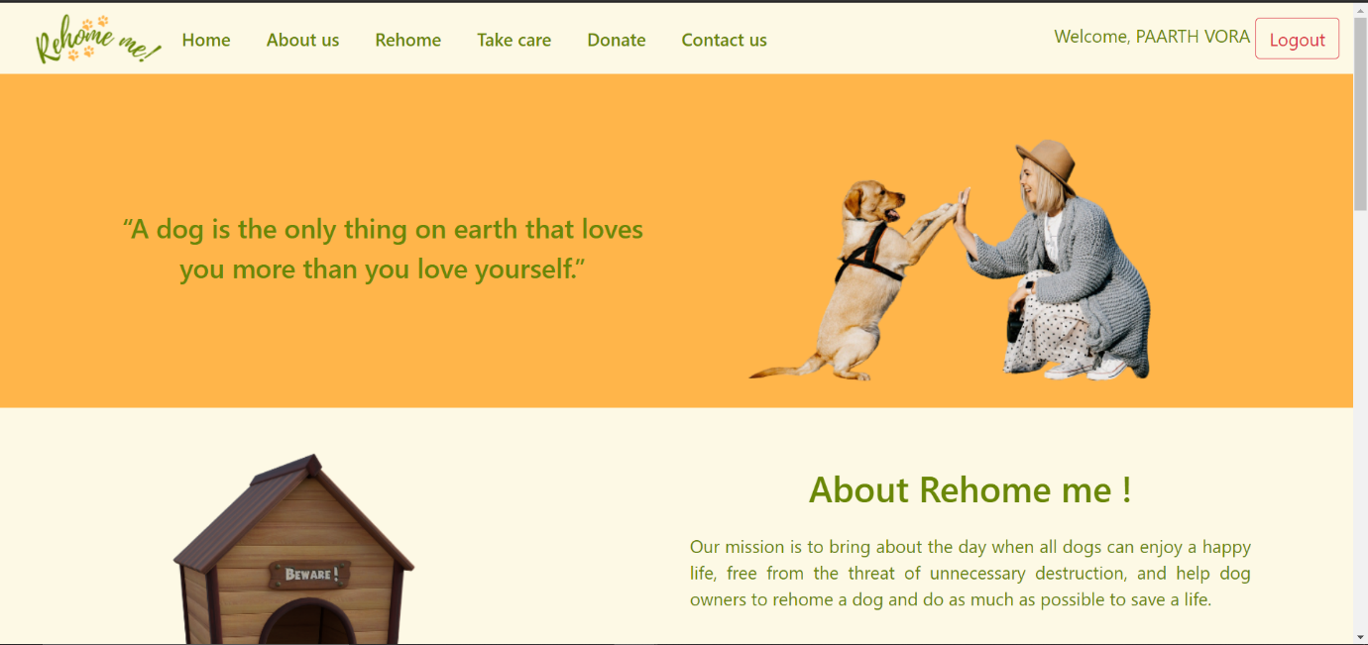
Fig. 4.1. Homepage.
When the user visits the page, they can see the home page where they can see many different options like Rehome, Take care, Donate.
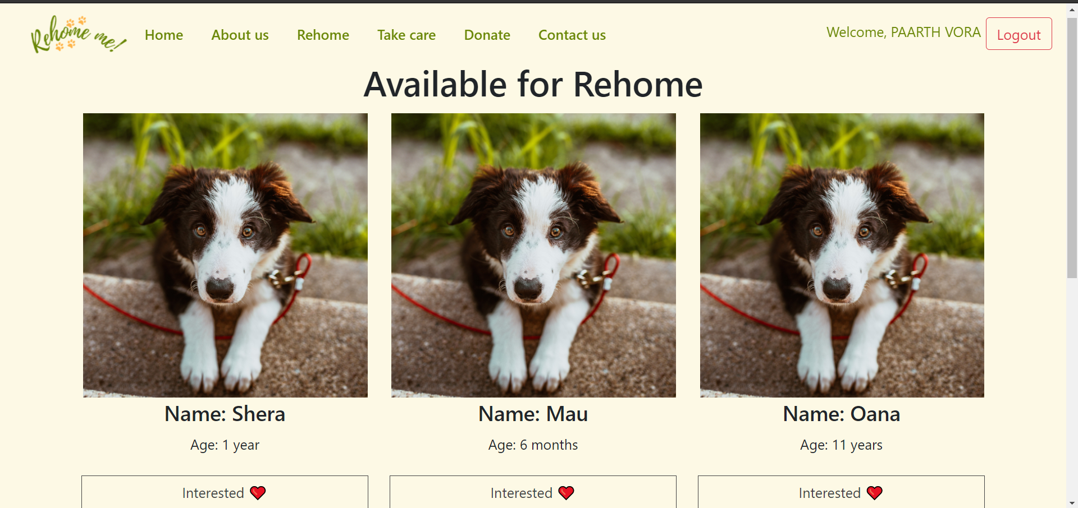
Fig. 4.1.1 Rehome.
When the user clicks on the rehome option, they will see the list of available dogs for rehoming. If they are willing to rehome one of the dogs available there, then have to click on the interested button and our one of our team members will contact the person.
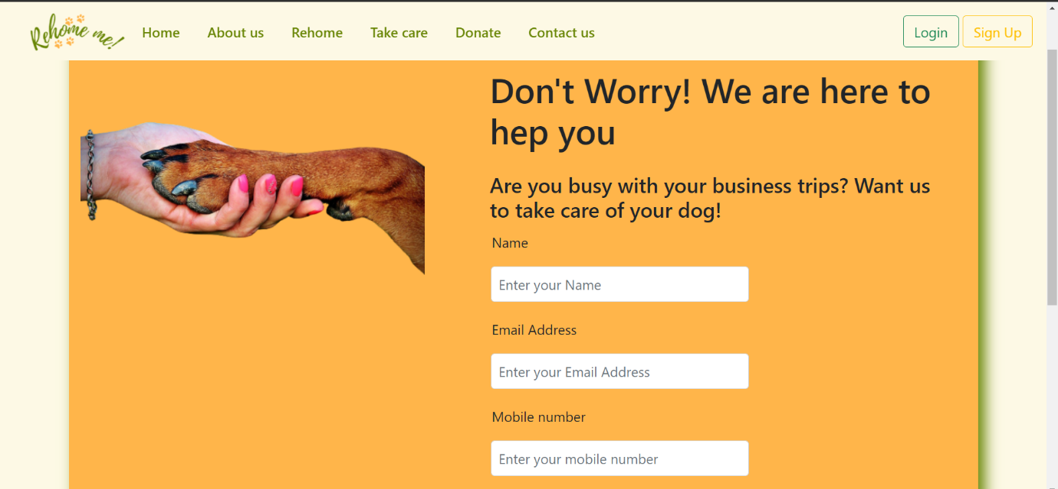
Fig. 4.1.2 Take care.
Take care is a unique feature in this web app. For example: If the somebody is very busy with the business trips or they are engaged in the work life that they cannot look after their dog. So, they can select this option and fill in some details and number of days they want us to take care of their dog and submit the form with a valid reason. Furthermore, they will be charged according to the standard daily expense of the dog.
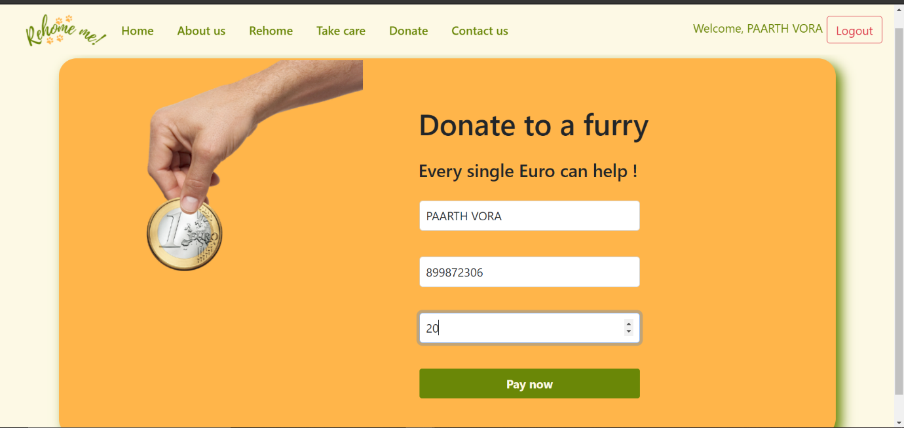
Fig. 4.1.3 Donate.
The web app also consists of a donate option for the people willing to donate some money that can be used to feed the stray dogs, treat the injured dogs and vaccinate the puppies. Similarly, there is a contact us form which can be used by the user to contact our team members.
- Web Service.
After creating the web app, it was deployed on Amazon web service which is a cloud platform used by web developers to deploy their web application (Amazon, 2015). There are two services used one is the Amazon EC2 and RDS, Where EC2 additionally grants admittance to the server-side instances and the code for the web app has been stored in EC2 and RDS is Amazon's relational database which is maintained through the SQL database. All the user information and the data will remain stored including backup of data in the RDS.
- Security.
As security is one of the most important aspects of web applications. So, for this web app, the IP whitelisting is done. It is a process where the developers can add the IP address of the trusted users in the list so that nobody else can access the database (Heron, 2009). It can only be accessed by the IP of the EC2.
- Conclusion.
After all this web application was created with many different and commonly used front-end and back-end framework and tools. The motive behind creating this web app is for rehoming dogs that are stray or abandoned by their owners and also find a solution for an individual who cannot take care of their dog for personal reasons.
- Learning Outcomes.
During the development of the web app Rehome me! I got to know about a lot of technologies and hands on experience on the coding language like HTML, CSS, JavaScript, jQuery and also got to learn about the flask framework. Moreover, during the deployment to cloud, I got the knowledge of AWS (Amazon Web Services) and its security feature that is known as IP whitelisting. So, with the research and planning I could successfully build a responsive and interactive web app.

- Links
Web app Link: http://3.248.224.53/
GitHub Link: https://github.com/paarthvora03/Rehome-me--web-app

- References.
- Mashevskiy, V., 2017. Front-End Web Development.
- Pilgrim, M., 2010. HTML5: up and running: dive into the future of web development. " O'Reilly Media, Inc.".
- Gasston, P., 2011. The book of CSS3: A Developer's Guide to the Future of Web Design. No starch press.
- Mikkonen, T. and Taivalsaari, A., 2007. Using JavaScript as a real programming language.
- Spurlock, J., 2013. Bootstrap: Responsive Web Development. " O'Reilly Media, Inc.".
- Chaffer, J. and Swedberg, K., 2011. Learning jQuery. Packt Publishing Ltd.
- Summerfield, M., 2010. Programming in Python 3: a complete introduction to the Python language. Addison-Wesley Professional.
- Copperwaite, M. and Leifer, C., 2015. Learning Flask Framework. Packt Publishing Ltd.
- DuBois, P., 2008. MySQL. Pearson Education.
- Leff, A. and Rayfield, J.T., 2001, September. Web-application development using the model/view/controller design pattern. In Proceedings fifth ieee international enterprise distributed object computing conference (pp. 118-127).
- Amazon, E.C., 2015. Amazon web services. Available in: http://aws. amazon. com/es/ec2/ (November 2012).
- Heron, S., 2009. Technologies for spam detection. Network Security, 2009(1), pp.11-15.

